Automation of J’s - Requirements Document
SWE 3313, Section 03
Team DS
21 March 2026

Table of Contents
Functional Requirements II-IX
System Access & Data Collection II-IV
User Functions IV-IX
Nonfunctional Requirements X-XI
Use Case Diagrams XII-XIII
Use Case Flow of Events XIV
Class Diagrams XV
Class Documentation XVI-XVII
ER Diagram XVIII
Decision Table XIX-XXI

Functional Requirements
System Access & Data Collection
- R.D.1 – The system shall collect and store data for customer turnaround time.
  - During operational hours, the system will collect data regarding how long customers spend within the restaurant (based on time durations of when a table is occupied to when a table is ready to be cleaned). This data will be stored with a MySQL database and organized to allow for easy identification of specific and average turnaround times during certain periods. This data is accessible only to the manager.
- R.D.2 – The system shall collect and store data for food preparation time.
  - During operational hours, the system will record the time duration for how long it takes for orders to be prepared and served. This data will be stored within a MySQL database and organized to allow for easy identification of specific and average turnaround times during certain periods. This data is accessible only to the manager.
- R.D.3 – The system shall collect data for menu item purchases and calculate and store the top 3 most popular items.
  - During operational hours, the system will record what menu items are purchased. This data will be stored within a MySQL database and categorized to easily determine item popularity during certain periods. This data is accessible only to the manager.
- SS.1 – Staff shall clock in and clock out via the system.
  - Within the system is a clock-in/out page where users click a but to clock in and, at the end of their shift, click the button again to clock out. While the user is clocked in, there is a button that the user will use when taking their lunch break and returning from break. The module here tracks the user’s clock-in and clock-out times, the current date, time spent on break, and the user’s total paid time (time clocked in and not on break).
- SS.Sa.1 – Each staff member shall have a 6-character, alphanumeric username.
  - The development team will assign a username to each current staff member according to the provided criteria. Post deployment, staff usernames will be assigned by the client company.
  - The usernames will be stored within staff profiles and will be used to verify user identity during the sign up and login processes.
- SS.Sa.2 – Each staff member shall first sign up to the system (using assigned username and creating a password).
  - Each staff member is provided their assigned username and can then proceed to sign up on the system. During the sign up process, the system uses the user’s username and other provided information (name and position) to identify the user and ensure they are a hired staff member. The user is then able to create a secure password that they can use to continue to access the system.
- SS.Sa.3 – Staff shall log in via a login screen.
  - The development team will create a login module to accept user in[ut for the user’s username and password. Both inputs will then be verified by the system using previously confirmed information to identify the user. If the user is unidentifiable, they are denied access to the system. If the user is identifiable, they are provided pre-determined access to certain functions/screens within the system to be able to efficiently complete their assigned duties.
- SS.D.1 – The system shall collect data of staff shift durations and calculate each staff member's earned wage.
  - The system shall collect data regarding each staff member’s shift for each scheduled workday (including clock-in/out times, total shift time excluding breaks, break times, and duration of breaks) and then store this data within a MySQL database. This data will only be accessible by the manager.
- SS.D.2 – The system shall collect and store data of the duration of staff’s breaks.
  - The system shall collect data regarding each staff member’s shift for each scheduled workday (including clock-in/out times, total shift time excluding breaks, break times, and duration of breaks) and then store this data within a MySQL database. This data will only be accessible by the manager.
- OP.D.1 – The system shall collect and store data for revenue.
  - During operational hours, the system will track revenue from each order and will record from which items each amount of revenue obtained. This data will be stored in a MySQL and categorized to allow for easy identification of how much revenue was earned during set periods and what percent of the revenue was obtained from specific menu items. This data can only be accessed by the manager.
- OP.D.2 – The system shall calculate and store data for revenue contribution percentage for each menu item.
  - During operational hours, the system will track revenue from each order and will record from which items each amount of revenue obtained. This data will be stored in a MySQL and categorized to allow for easy identification of how much revenue was earned during set periods and what percent of the revenue was obtained from specific menu items. This data can only be accessed by the manager.
User Functions
- R.1 – The manager shall use the system to view inventory and order supplies.
  - The development team will create a module to allow the manager to view the current documented inventory status/numbers. The manager will be able to specify a minimum amount for each supply item and when this amount, or below, is detected, the manager is notified.
  - The development team will develop a module that allows the manager to submit supply orders. The manager selects the option to “order supplies,” selects the specific supply items to order, determines the amount of each order to buy, and selects the supplier company from which to order. The manager then submits this information as a completed order.
- R.2 – The manager shall use the system to set minimum amounts for inventory items and shall receive notifications when the amount is reached.
  - The development team will create a module to allow the manager to view the current documented inventory status/numbers. The manager will be able to specify a minimum amount for each supply item and when this amount, or below, is detected, the item is shown under an on-screen list of items (the list is titled “Low Supplies”).
- R.3 – The manager shall use the system to update menu items and prices.
  - The development team will create a module that allows the manager to view and edit menu items. The manager can select specific menu items and choose to either “update price” or “remove item.”
    - When menu prices are updated, the system does not update this change until two hours before the start of the next workday.
    - When menu items are removed, the system does not update this change until two hours before the start of the next workday.
- SS.2 – The manager shall use the system to create, update, and delete staff profiles.
  - The development team will create a module that allows the manger to select “create profile” or select current staff profiles to “update” or “remove.”
  - If the manager is creating a profile, they are required to input a first name, last name, [assigned] username, [assigned] work email, job position, and hourly rate. The manager can then submit this information, and the new profile is created/saved.
  - If the manager selects an existing profile and selects the “update” option, they can provide or edit most information. The staff’s name, hourly rate, username, work email, and birthdate cannot be edited.
  - If the manager selects an existing profile and selects the “remove” option, the profile is removed from the manager’s view, the system, and the database.
  - All profile data is also saved in a MySQL database.
- SS.3 – The manager shall use the system to assign shifts.
  - The development team will create a module that allows the manager to view a calendar and assign staff to specific shifts. The manager can view every month for the entire year. The manager can view staff names for the day that they are assigned.
  - The manager can assign shifts by selecting a staff member’s name (listed on the side of the screen) and input days and times for the staff to work.
- SS.4 – The manager shall use the system to assign tables to waiters.
  - The manager can select a staff’s profile and assign to them tables by inserting the table ID or IDs into the designated input space.
- T.1 – Busboys shall manage tables with the ability to change their status from dirty (red) to ready (green).
  - The development team will create a module to allow for busboys to view tables and adjust their status. Tables show as red if the status is dirty, green if the status is clean/available, and yellow if the status is occupied. The busboy can select red tables and change the status to green when they have cleaned it. The busboy cannot access any table that is not red.
- T.2 – Waiters shall manage tables with the ability to change their status from ready (green) to occupied (yellow), and from occupied to dirty (red).
  - The development team will create a module to allow for waiters to view tables and adjust their status. Tables show as red if the status is dirty, green if the status is clean/available, and yellow if the status is occupied. The waiter can select a green table and update it to yellow or select a yellow table and update it to red. The waiter cannot select/update red tables.
- OP.1 – Waiters shall use the system to take customer orders which, when completed, can be viewed by cooks.
  - The development team will create a module for the waiter to record customers’ orders, while the system automatically calculates the price as items are added or removed. When the waiter submits the order, the order is saved with identifying details (table number, waiter name or username or ID, table’s seat ID) and is made accessible to kitchen staff for viewing.
- OP.2 – Waiters shall use the system to take cash or card payments.
  - The development team will create a module that allows the waiter to select cash or card payment method. This module uses order details to identify for which table and which specific items the payment is for/applied to.
  - The cash method allows for the amount to be entered and then submitted.
  - The card method allows for card information to be entered and then submitted.
  - When the payment has been submitted, a receipt document is created that can be emailed to the customer. The receipt contains the waiter’s first name and last initial, each ordered item along with its price, the current date, and the payment method used. This receipt is stored in the system and can be accessed only by the waiter that managed the payment. All receipts are accessible until 48 hours have passed since the payment was made.
- OP.3 – Waiters shall use the system to request refunds on behalf of customers; these requests are sent to the manager to deny or permit.
  - The development team will create a module that allows waiters to view all receipts for orders that they managed within the past 48 hours. The waiter can select a specific receipt to view it or to request a refund. When a waiter selects the refund request option, they can input the specific item for which a refund is requested and the reason why. When this information has been submitted, a notification is sent to the manager.
    - If the manager denies the request, the waiter can view their submitted reason. No changes are made to the company revenue or to the receipt. A Refund Request document is created that can be emailed to the customer. Like the receipt, this document is saved, for the specific waiter, until after 48 hours since its creation.
    - If the manager accepts the request, the refunded amount is noted and applied by the system to revenue data. A new receipt document is created that makes note of the refund. This document can be emailed to the customer. Like the original receipt, this document is saved, for the specific waiter, until after 48 hours since its creation.
  - The development team will create a module that allows the manager to receive refund requests, view the details of the request, and submit a response in the form of “deny” or “accept.” The details of the request that the manager can view are:
    - The date of purchase for the item.
    - The payment method.
    - The waiter and table name/ID.
    - The date of the refund request’s submission.
    - The waiter-provided details regarding which item a refund is being requested for and the reason for the request.
- OP.4 – Cooks shall view submitted orders and, once completed, clear the order and notify the appropriate waiter of the available item.
  - The development team will create a module that allows cooks to view submitted order as well as the waiter’s name and table ID for that order. The cook can mark the order’s completion. When orders are marked “complete” the specific waiter is notified.

Nonfunctional Requirements
- P.1 – The development team shall ensure the user’s ability to use as few keystrokes and clicks as possible.
  - During and after testing phases, the development team will navigate through the system, multiple times and through different paths, to review how many clicks the user has to make to complete tasks. The number is documented after each run through and changes are proposed, discussed, implemented, and tested to reduce clicks when possible.
- P.2 – The development team shall provide user support to ensure easier integration and use of the system into the restaurant’s day-to-day operations.
  - During the engineering process, the development team will create and update documentation relating to architecture designs, process demonstration videos, and a manual describing the functions of the system relating to different, anticipated, tasks.
- P.3 – The system shall be accessible and operational on both touch screen and keyboard-operated devices.
  - During the engineering process, the development team will account for both keyboard and touch inputs to allow for interaction with the system on multiple devices.
- P.Se.1 – The development team shall ensure that the system is protected/secured from external breeches to the system or to private data.
  - During the testing phases, the development team will attempt to access the system as external users.
  - During the testing phase, the development team will screen and enlist external testers to attempt to access the system as external users.
- P.Se.2 – The development team shall ensure that the database is secured to prevent external or internal illegal accesses to restricted data.
  - During the testing phases, the development team will attempt to access various data within the database while interacting with the system under a specific role/set of permissions.
  - During the testing phase, the development team will screen and enlist external testers to interact with the system and attempt to access the database.

Use Case Diagrams
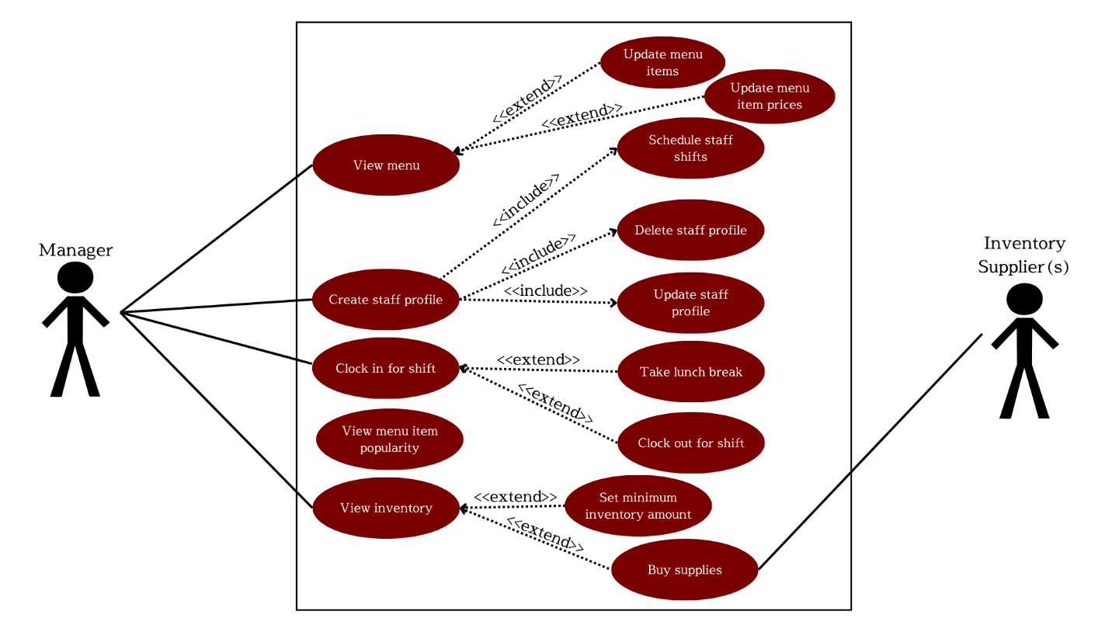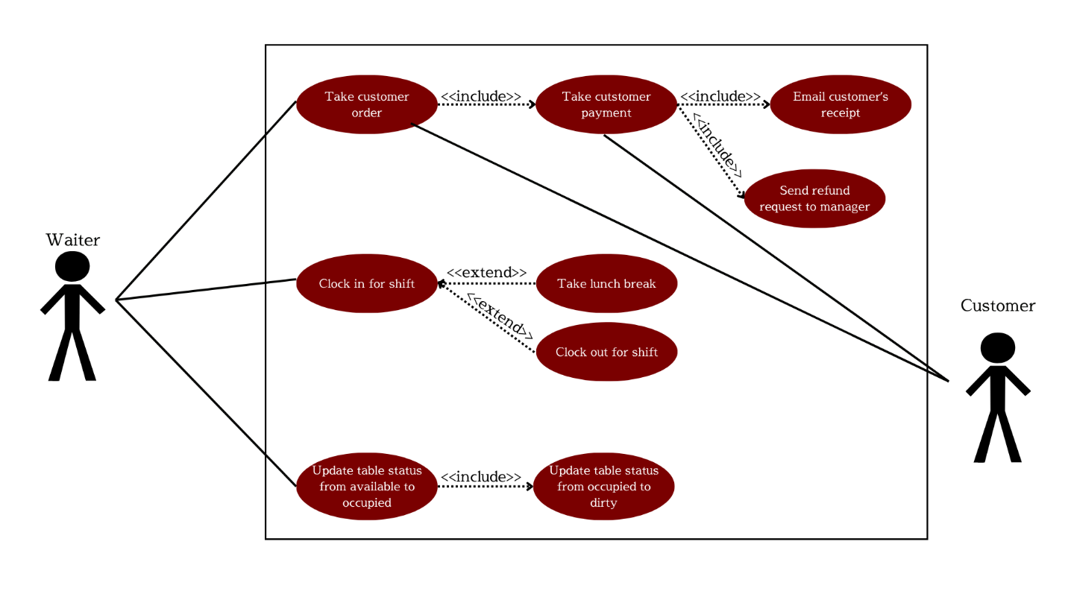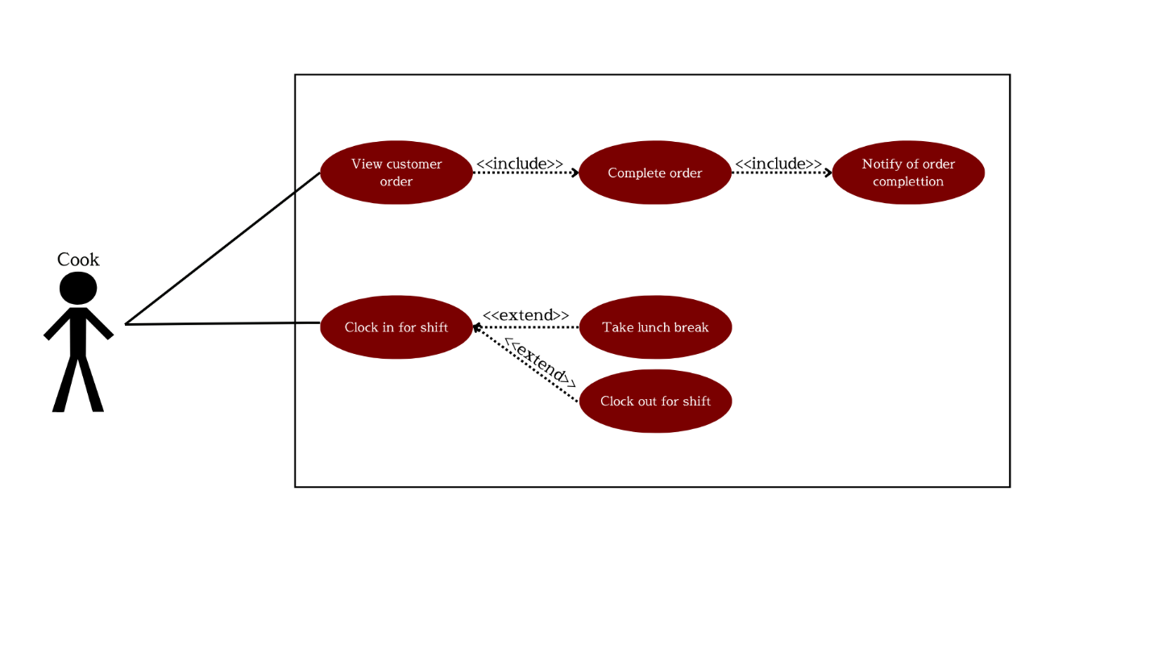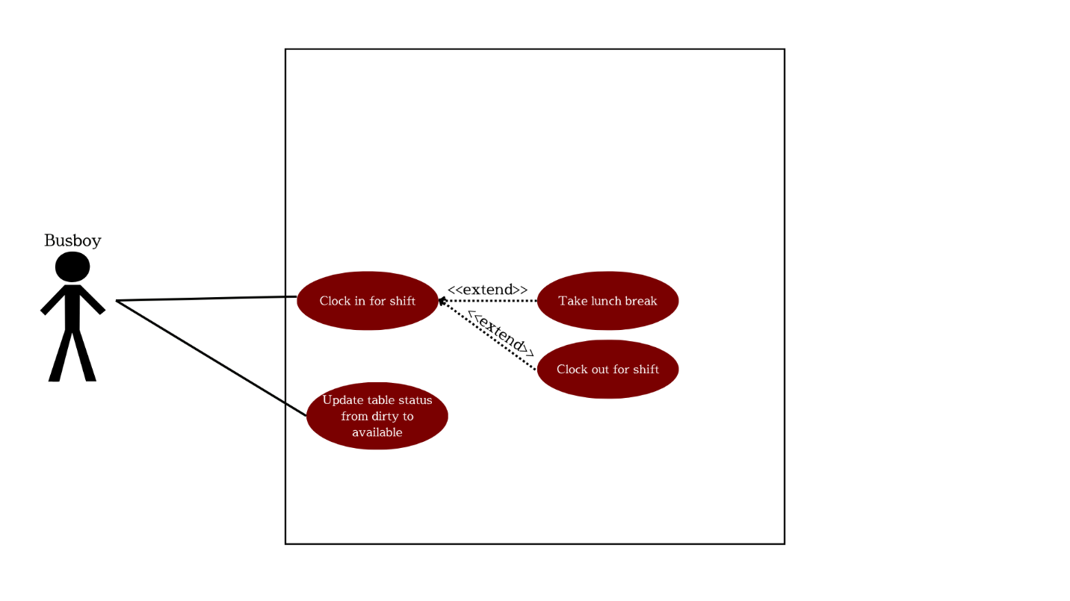

Use Case Flow of Events
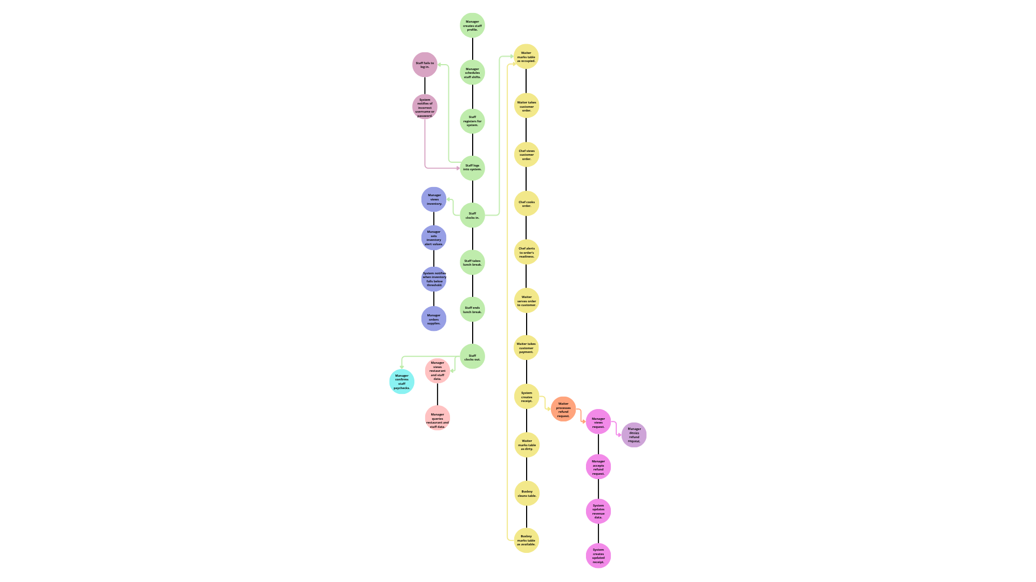
Automation of Js Flow of Events.pdf
Class Diagrams
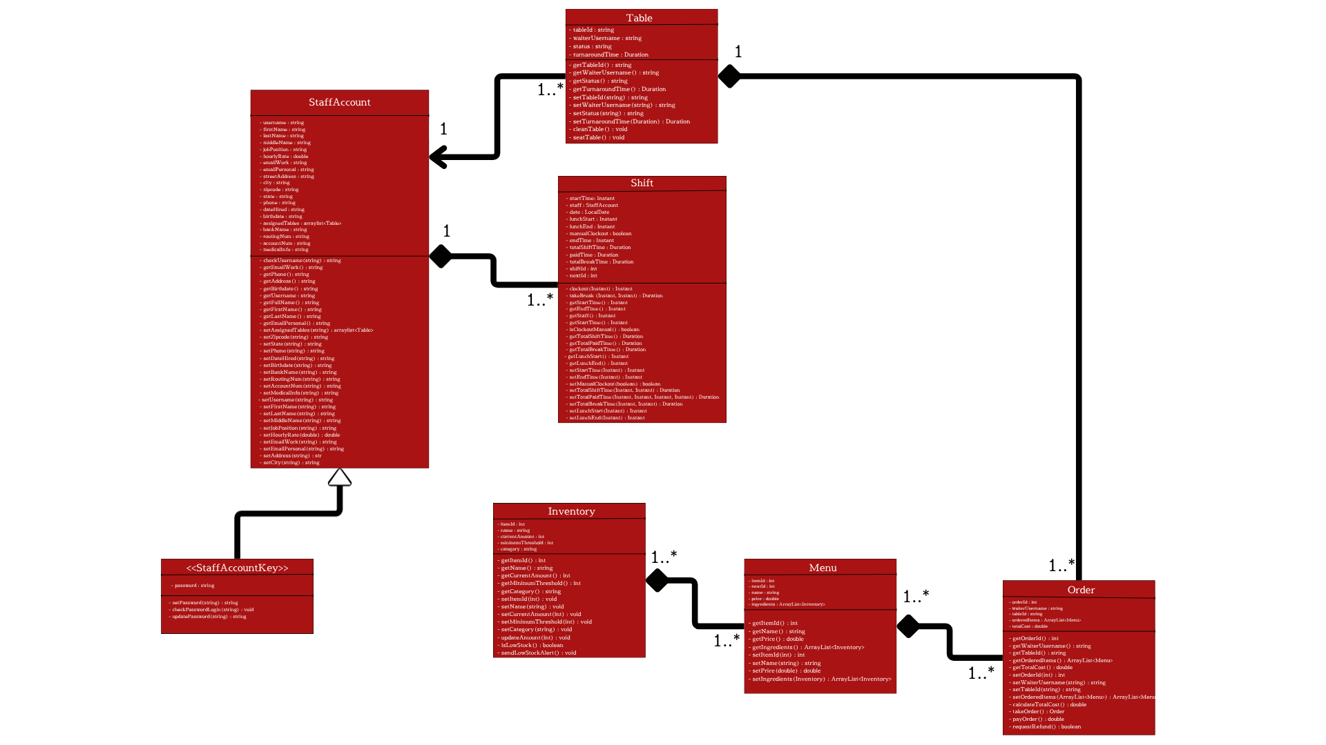
Automation of Js Class Diagram.pdf

Class Documentation
StaffAccount class : Each object of this class represents a staff member of J’s Corner Restaurant. Each object records the staff members’ data regarding personal identification, work identification, contact information, payment information, and a unique ID and unique username. The StaffAccount class is used by the system to verify sign up and login information, record shift data, record data needed to make payments
StaffAccountKey class : A child class of StaffAccount, StaffAccountKey objects store and connect each staff member’s password. This class also contains methods to be used for password validation. One method is called during sign up to ensure creation of a valid password and the other is called during login to ensure that the provided password is correct and connects with the provided username.
Shift class : The objects of Shift represent each shift that a staff member works; it is linked to StaffAccount by staff’s ID/username. This class helps in managing staff’s wages by tracking their paid time and calculating it with their hourly rate (data provided in StaffAccount). This class also gathers data for the database regarding the duration of staff members’ breaks.
Table class : Each object of Table class represents a table within J’s Corner Restaurant. The objects store the ID/username of the waiter assigned to them. The class also enables the collection of data relating to order preparation time, customer turnaround time, and table preparation time. The class also facilitates waiter and busboy functions of updating a table’s status.
Inventory class : Each object of Inventory represents a supply category/type currently stored at J’s Corner Restaurant. These range from ingredients, to cleaning supplies, to serving utensils, and any other items needed for the restaurant’s day-to-day operations. The class stores the inventory item’s ID, name, and current amount (this value is frequently updated and is affected in part by Order class). It also calls methods that allow the manager to set minimum amounts and then send alerts when those amounts have been reached; this is to encourage quick supply restock.
Menu class : Each object of Menu represents an item offered by J’s Corner Restaurant. The objects store the item’s price and an arraylist of ingredients used to make the item. This arraylist attribute contains objects of type Inventory; it’s purpose is to aid in tracking the amount of available supplies. The class is, also, linked to an arraylist of type Menu that stores and displays all offered items. The class is connected to an Order class method that calls each object’s price and calculates the customer’s total cost.
Order class : Each object of Order represents an order taken for a customer of J’s Corner Restaurant. The order contains an ID number and an arraylist of type Menu that contains each item requested. The class also contains a method to calculate the total cost of these items, including tax. A second and third method are defined to facilitate payment and request refunds. This revenue data is stored in the database.

ER Diagrams
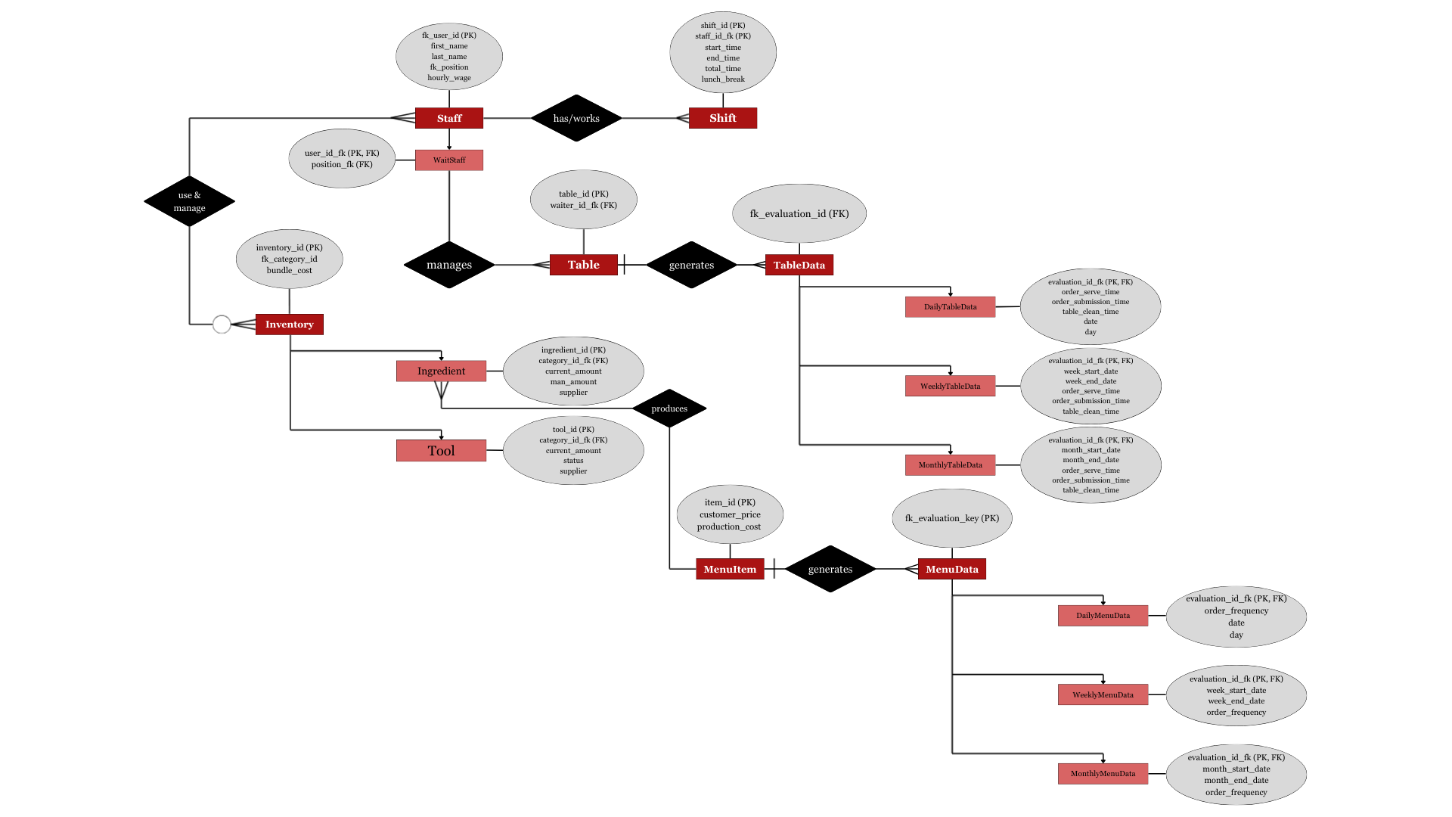

Decision Tables
Login Function
Condition
Username | Correct | Correct | Blank | Blank | Incorrect | Correct | Incorrect | Incorrect | Blank
Password | Correct | Blank | Correct | Blank | Incorrect | Incorrect | Correct | Blank | Incorrect
Action
Successful Login | Execute
Error |  | Execute | Execute | Execute | Execute | Execute | Execute | Execute | Execute

Sign Up Function : Creating Password
Condition
Password has at least One of Every Required Character Type | Yes | Yes | No | Yes | Yes | No | No | No
Password has at least Eight Characters | Yes | Yes | Yes | No | No | Yes | No | No
Password has Less Than Sixteen Characters | Yes | No | Yes | Yes | No | No | Yes | No
Action
Store Password | Execute
Error |  | Execute | Execute | Execute | Execute | Execute | Execute | Execute

Table Management
Condition
Table is Dirty | True | False | False
Table is Occupied | False | True | False
Table is Available | False | False | True
Action
Waiter can mark as dirty |  | Execute | Execute
Waiter can mark as occupied |  |  | Execute
Busboy can mark as available | Execute

Order Management
Condition
Customer Requests Item | True |  | True
Customer service No Longer Wants Item | True | True
Customer Confirms Order Requests |  |  |  | True
Action
Add Item to Order | Execute |  | Execute
Remove Item from Order | Execute | Execute
Order Price Adjusted | Execute | Execute | Execute
Order is Submitted |  |  |  | Execute

Order Payment (via Card)
Condition
Card Number | Valid | Valid | Valid | Valid | Not Valid | Not Valid | Valid | Not Valid | Valid | Valid | Not Valid | Not Valid | Not Valid | Not Valid
CVV | Valid | Valid | Valid | Not Valid | Valid | Valid | Not Valid | Valid | Not Valid | Not Valid | Valid | Not Valid | Not Valid | Not Valid
Name on Card | Valid | Valid | Not Valid | Valid | Valid | Not Valid | Valid | Valid | Not Valid | Not Valid | Not Valid | Valid | Not Valid | Not Valid
Billing Address | Valid | Not Valid | Valid | Valid | Valid | Valid | Not Valid | Not Valid | Valid | Not Valid | Not Valid | Not Valid | Valid | Not Valid
Action
Accept Payment and Create Receipt | Execute
Error |  | Execute | Execute | Execute | Execute | Execute | Execute | Execute | Execute | Execute | Execute | Execute | Execute | Execute

Order Payment (via Cash)
Condition
Customer Name | Yes | Blank | Blank | Yes | Yes | Blank | Yes | Blank
Cash Value Input | Yes | Blank | Yes | Blank | Blank | Yes | Yes | Blank
Customer Signature | Yes | Yes | Blank | Blank | Yes | Yes | Blank | Blank
Action
Accept Payment and Create Receipt | Execute
Error |  | Execute | Execute | Execute | Execute | Execute | Execute | Execute

Cook Functions
Condition
Order Comes In | True
Order is Prepared |  | True | True
Waiter Retrieves Order |  |  | True
Action
Click Order to View Details | Execute
Notify of Order Completion |  | Execute
Clear Order from View |  | Execute | Execute

Inventory Alert Management
Condition
Inventory is Above Set Minium | True
Inventory Equals Set Minimum |  | True | True
Inventory is Below Set Minimum |  |  | True
Action
Alert Manager
Alert Manager |  | Execute | Execute

